AI Video Summarization and Quiz Generation using Mixtral, Whisper and AWS

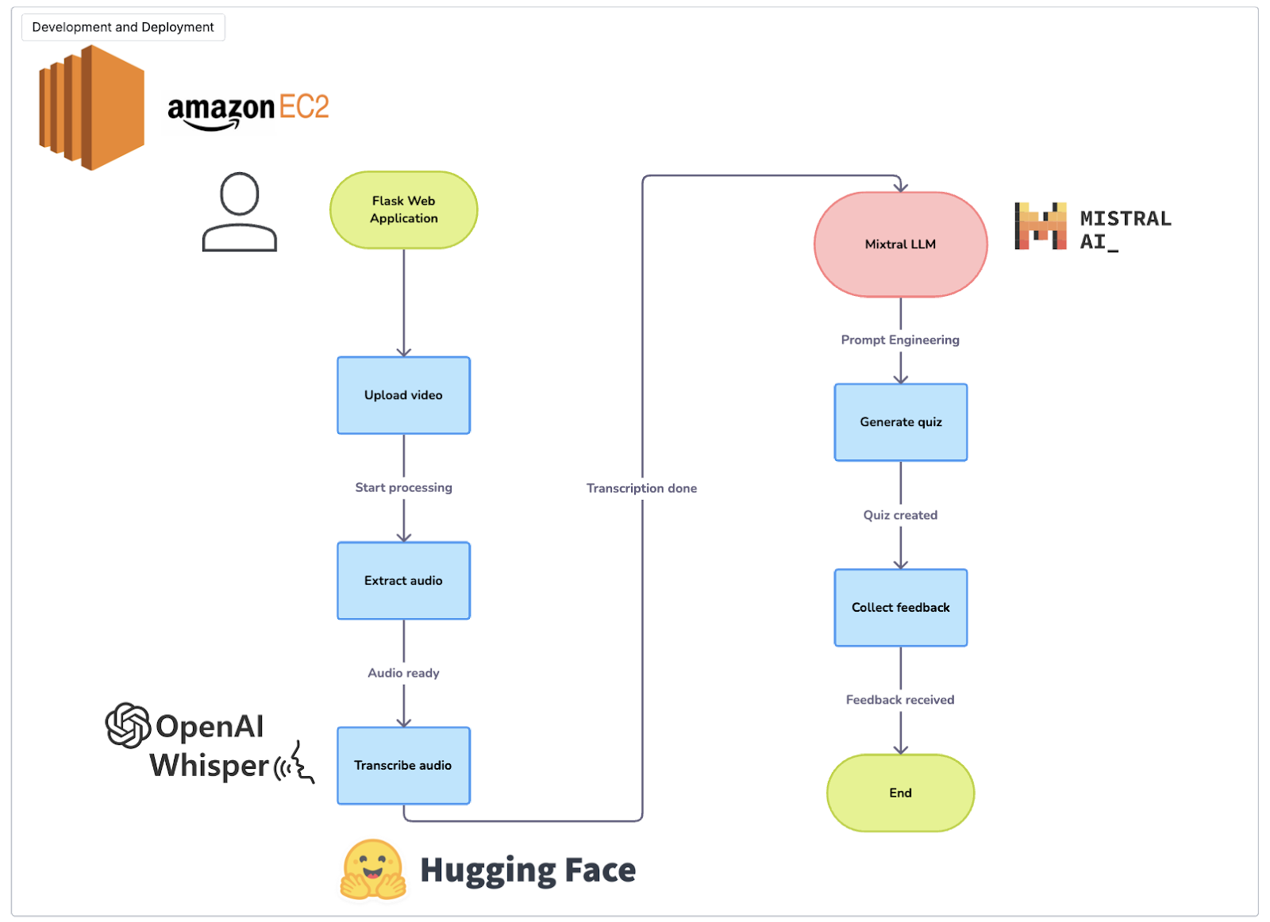
Project Overview
The growing popularity of video-based learning has created challenges for learners trying to extract key concepts and retain important information efficiently. Educational videos often contain valuable insights, but reviewing long videos can be time-consuming.
This project develops an AI-powered Video Summarization and Quiz Generation platform that leverages Whisper and Mixtral models to automatically transcribe educational videos, generate concise summaries, and create quizzes for knowledge assessment.
The solution uses AWS cloud infrastructure for scalable processing and provides a user-friendly interface for uploading videos and receiving AI-generated learning material.
Aim
Develop an intelligent video summarization and quiz generation application using Large Language Models and AWS to improve learning efficiency and knowledge retention.
Data Description
Input:
- Educational tutorial videos
- Machine Learning concepts
- Technical training content
Output:
- Video transcripts
- AI-generated summaries
- Dynamic quizzes
- User feedback
Tech Stack
Language:
- Python 3.10.4
Libraries:
- Flask
- FFmpeg
- Torch
- Transformers
- SQLAlchemy
Models:
- Mixtral
- Whisper
Cloud Platform:
- Amazon Web Services (AWS)
Approach
1. Environment Setup
- Configure AWS EC2 GPU instance
- Install required dependencies
2. Model Selection
- Whisper for speech-to-text transcription
- Mixtral for summarization and quiz generation
3. Audio Extraction
- Extract audio using FFmpeg
- Preprocess media content
4. Video Transcription
- Convert speech into text
- Generate accurate transcripts
5. AI Summarization
- Extract key concepts
- Generate concise learning summaries
6. Quiz Generation
- Create quizzes from summaries
- Support multiple difficulty levels
7. User Interface Development
- Video upload functionality
- Interactive quiz interface
8. Feedback Mechanism
- Collect learner feedback
- Store feedback for analysis
Project Structure
app/
├── database.py
├── data_models/
│ ├── feedback.py
│ └── __init__.py
├── mixtral_prompts.py
├── mixtral_wrapper.py
├── routes.py
├── templates/
│ └── index.html
├── utils.py
├── whisper_wrapper.py
└── __init__.py
finetune.py
run.py
readme.md
requirements.txt
File Description
database.py
- Database configuration and management
feedback.py
- User feedback data model
mixtral_wrapper.py
- Mixtral integration for summarization and quiz generation
whisper_wrapper.py
- Whisper speech-to-text processing
routes.py
- Flask routing and APIs
index.html
- Frontend interface
run.py
- Application entry point
Project Takeaways
1. Video Summarization Systems
2. Quiz Generation using LLMs
3. Whisper Speech-to-Text
4. Mixtral LLM Integration
5. Audio Processing with FFmpeg
6. AWS EC2 GPU Deployment
7. Prompt Engineering
8. Flask Application Development
9. User Feedback Loops
10. Educational AI Platforms
11. AI-Powered Learning Systems
12. Dynamic Content Generation
Business Benefits
- Faster learning and revision
- Improved knowledge retention
- Automated educational content generation
- Reduced manual summarization effort
- Scalable AI-powered learning platform
- Enhanced learner engagement

